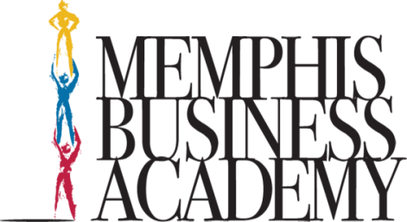
The MBA Experience: Growing Tomorrow's Leaders to Transform Lives and Communities

Board Meeting
May 17, 2023

Ms. Bobo Mr. Wilson
Mrs. Sanders Rev. Beasley
Mr. Thornton Mrs. Clark
Mr. Thurman Mr. Thomas
Mr. Reeder Dr. Bradley
Mrs. Norment Mr. McCain
Rev. Anderson Ms. Cox (via phone)

- Ms. Bobo presented a power point dedicating today’s meeting to our former board member, Ms. Barbara Bennett. She passed away in March.
- Dr. Bradley spoke about our Pre-K program and presented attendance for all schools.
- Also, she gave updates regarding grants awarded to MBA & MSA
- Over 5 million in scholarships were awarded to MBA students.
- Mr. Thurman spoke about 3rd grade retention. If they fail, they must attend summer school. They are only allowed to miss one day of summer school.
- Mrs. Sanders provided facilities updates:
Classroom modulars are going in at Hickory Hill campus.
Cherokee clinic is leaving Harmony Plaza.
- Rev. Anderson spoke about replacing board members.
- Recommendations: Martin McClain and Glenda Clark
- Mr. Reeder motioned for both candidates and Mr. Thomas 2nd the motion.
- Mr. Reeder is stepping down as Chairman of the board. He is suggesting Mr. Thornton as the new Chairman.
- The Board accepted Mr. Reeder’s resignation.
- Mr. Thornton accept position as new Board Chairman.
- Votes---Mr. Thomas yes; Ms. Cox yes; Mr. Beasley yes
- Next meeting August 23, 2023, at 3:00pm

